Keith Wheeler

CS165

Brother Comeau

Project 2

Advanced Skeet

Problem Description – A game that will have 3 types of birds that are shot by a rifle.

Overview – The user will input the right and left button to turn the rifle and the space button to shoot a bullet in the direction the rifle is pointing. There will be a normal, strong and safe bird. The normal bird will be a circle and will die with one hit and the strong bird will have a number in the middle and when that number hits zero the bird is dead. The safe bird will be a star and will be -50 points if hit.

Interface Design –

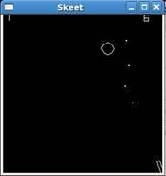 The rifle will be at the bottom right of the screen and will be able to spin from the right side of the screen to the bottom side of the screen. The birds will start from any point on the left, top and right and go to the other side in a wrap pattern. The score will be displayed at the top left of the screen and the missed birds will be at the top right of the screen.

Structure Chart –

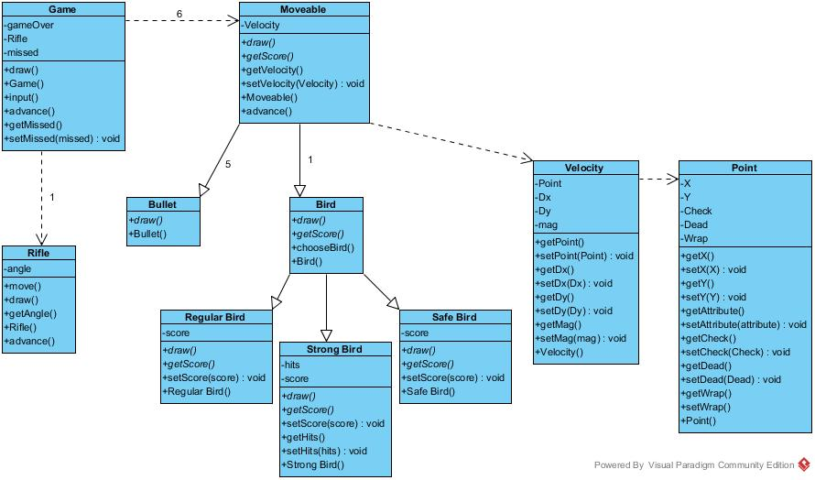

Data Structures – Point has a float X and a float Y coordinate to show what position the object has. Velocity has a float Dx and a float Dy to show the point the object will move to. The score will be passed as an integer to game. Angle will show the angle of the rifle to game so that the bullet can go the right direction. The mag will show the magnitude of the object.

Algorithm Design –

Error Handling –